**SQL ASSIGNMENT**

**Query 2**

1. **Display THE NUMBER OF packages developed in EACH language.**

**Query:** SELECT dev_in LANGUAGE,COUNT(title) NO_of_PACK FROM sql_query.software GROUP BY dev_in;

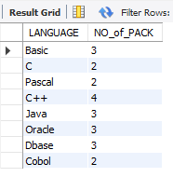

1. **Display THE NUMBER OF packages developed by EACH person.**

**Query**: SELECT name,COUNT(title) No_of_Pack FROM sql_query.software GROUP BY name;

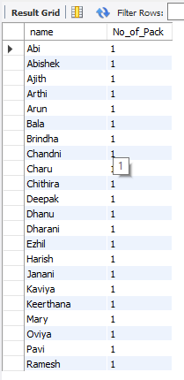

1. **Display THE NUMBER OF male and female programmer.**

**Query:** SELECT sex,COUNT(name) FROM sql_query.programmer GROUP BY sex;

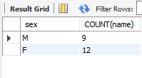

1. **Display THE COSTLIEST packages and HIGEST selling developed in EACH language.**

**Query:** SELECT dev_in,MAX(scost),MAX(sold) FROM sql_query.software GROUP BY dev_in;

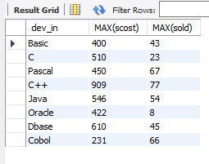

1. **Display THE NUMBER OF people BORN in EACH YEAR.**

**Query:** SELECT date_format(dob,'%Y') AS YEAR,COUNT(name) FROM sql_query.programmer GROUP BY date_format(dob,'%Y');

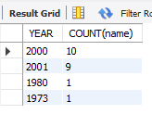

1. **Display THE NUMBER OF people JOINED in EACH YEAR.**

**Query:** SELECT date_format(doj,'%Y') AS YEAR,COUNT(name) FROM sql_query.programmer GROUP BY date_format(doj,'%Y');

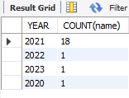

1. **Display THE NUMBER OF people BORN in EACH MONTH.**

**Query:** SELECT SUBSTR(dob,4,3),COUNT(name) FROM sql_query.programmer GROUP BY SUBSTR(dob,4,3);

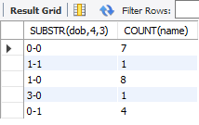

1. **Display THE NUMBER OF people JOINED in EACH MONTH.**

**Query:** SELECT SUBSTR(doj,4,3),COUNT(name) FROM sql_query.programmer GROUP BY SUBSTR(doj,4,3);

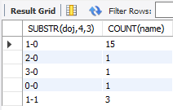

1. **Display the language wise COUNTS of prof1.**

**Query:** SELECT prof1, COUNT(prof1) FROM sql_query.programmer GROUP BY prof1;

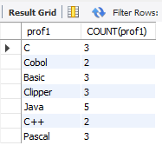

1. **Display the language wise COUNTS of prof2.**

**Query:** SELECT prof2, COUNT(prof2) FROM sql_query.programmer GROUP BY prof2;

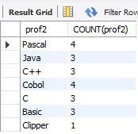

1. **Display THE NUMBER OF people in EACH salary group.**

**Query:** SELECT salary,COUNT(name) FROM sql_query.programmer GROUP BY salary;

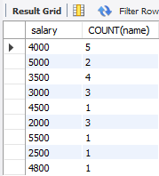

1. **Display THE NUMBER OF people who studied in EACH institute.**

**Query:** SELECT splace,COUNT(name) FROM sql_query.studies GROUP BY splace;

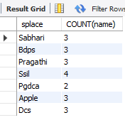

1. **Display THE NUMBER OF people who studied in EACH course.**

**Query:** SELECT course ,COUNT(name) FROM sql_query.studies GROUP BY course;

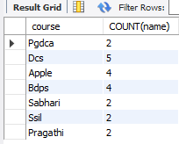

1. **Display the TOTAL development COST of the packages developed in EACH language.**

**Query:** SELECT dev_in LANG,SUM(dcost) TOTAL_COST FROM sql_query.software GROUP BY dev_in;

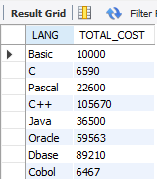

1. **Display the selling cost of the package developed in EACH language.**

**Query:** SELECT dev_in ,SUM(scost) FROM sql_query.software GROUP BY dev_in;

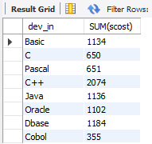

1. **Display the cost of the package developed by EACH programmer.**

**Query:** SELECT name,SUM(dcost) AS TOTAL_COST FROM sql_query.software GROUP BY name;

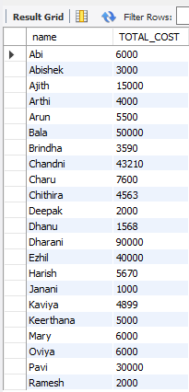

1. **Display the sales values of the package developed in EACH programmer.**

**Query:** SELECT name, SUM(scost*sold) FROM sql_query.software GROUP BY name;

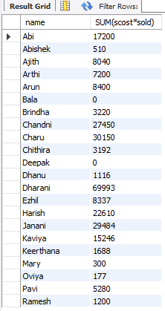

1. **Display the NUMBER of packages developed by EACH programmer.**

**Query:** SELECT name,COUNT(title) AS TOTAL_PACK FROM sql_query.software GROUP BY name;

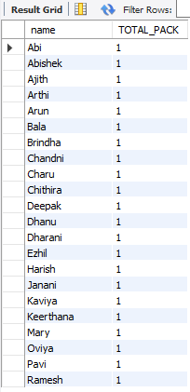

1. **Display the sales COST of packages developed by EACH programmer language wise.**

**Query:** SELECT dev_in, SUM(scost) FROM sql_query.software GROUP BY dev_in;

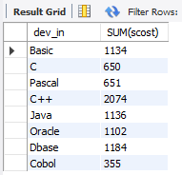

1. **Display EACH programmers name, costliest package and cheapest packages developed by Him/Her.**

**Query:** SELECT name,MIN(dcost),MAX(dcost) FROM sql_query.software GROUP BY name;

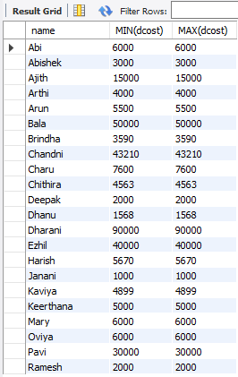

1. **Display EACH language name with AVERAGE development cost, AVERAGE cost, selling cost and AVERAGE price per copy.**

**Query:** SELECT dev_in,AVG(dcost),AVG(scost),AVG(scost) FROM sql_query.software GROUP BY dev_in;

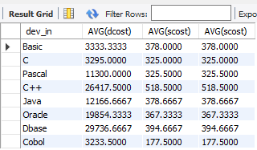

1. **Display EACH institute name with NUMBER of courses, AVERAGE cost per course.**

**Query:** SELECT splace,COUNT(course), AVG(ccost) FROM sql_query.studies GROUP BY splace;

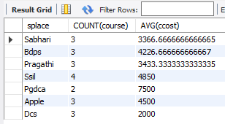

1. **Display EACH institute name with NUMBER of students.**

**Query:** SELECT splace,COUNT(name) FROM sql_query.studies GROUP BY splace;

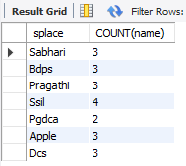

1. **Display names of male and female programmers.**

**Query:** SELECT name,sex FROM sql_query.programmer ORDER BY sex;

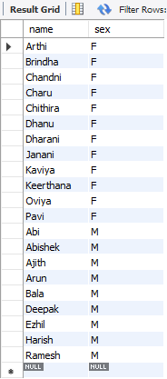

1. **Display the programmer's name and their packages.**

**Query:** SELECT name,title FROM sql_query.software ORDER BY name;

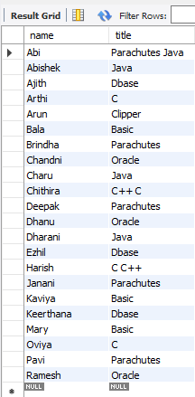

1. **Display the NUMBER of packages in EACH language.**

**Query:** SELECT COUNT(title),dev_in FROM sql_query.software GROUP BY dev_in;

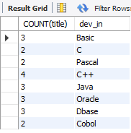

1. **Display the NUMBER of packages in EACH language for which development cost is less than 1000.**

**Query:** SELECT COUNT(title),dev_in FROM sql_query.software WHERE dcost<1000 GROUP BY dev_in;

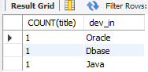

1. **Display the AVERAGE difference BETWEEN scost and dcost for EACH language.**

**Query:** SELECT dev_in,AVG(dcost - scost) FROM sql_query.software GROUP BY dev_in;

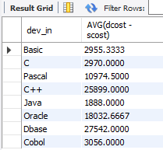

1. **Display the TOTAL scost, dcsot and amount TOBE recovered for EACH programmer for whose dcost HAS NOT YET BEEN recovered.**

**Query:** SELECT SUM(scost), SUM(dcost), SUM(dcost-(sold*scost)) FROM sql_query.software GROUP BY NAME HAVING SUM(dcost)> SUM(sold*scost);

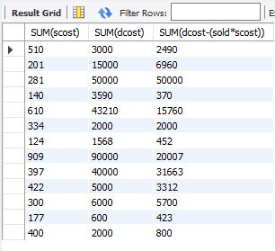

1. **Display highest, lowest and average salaries for THOSE earning MORE than 2000.**

**Query:** SELECT MAX(salary), MIN(salary), AVG(salary) FROM sql_query.programmer WHERE salary > 2000;

